PROJECT REPORT ON

WORLD OF CHOCO BOUTIQUE

ANSARI SHAHIRA SHABBIR

ACADEMIC YEAR 2022-2023

PROJECT GUIDE

Prof. Abhishek Gulati

Prof. Vicky Patil



SUBMITTED TO

MICROSOFT AZURE

**World of Choco Boutique**

**Aim**

To deploy a website on Azure, establish a custom URL via DNS. Additionally, setting up a web alert rule, and employ access restrictions to prevent malicious users from accessing the website.

**Procedure**

**Step1:** Establish a Virtual Network (V-Net) that contains a subnet, and within that subnet, place a Virtual Machine (VM).

**Step2:** Create a web service using App Service.

**Step3:** Establish a connection to the VM, install FileZilla within the VM, & deploy a website through FileZilla.

**Step4:** We can paste the URL of web app on the internet we will be able to see the website.

**Step5:** We can change the URL of the web app by custom domain with the help of hostinger. We will be able to view the website through our domain

**Step6:** Create an alert rule for web app.

**Step7:** Create an access restriction.

**Diagram**

V-Net1 – Central India – 10.0.0.0/16

To deploy a website on Azure, establish a custom URL via DNS. Additionally, setting up a web alert rule, & employ access restrictions to prevent malicious users from accessing the website.

Subnet1 – 10.0.0.0/24

VM1 – Private IP – 10.0.0.4

Public IP add 4.224.82.255

1

Deploying a website with the help of FTPS via FileZilla.

2

Copy the URL of web app on google. You will be able to view the website.

Web App

**Note:**

You can access the website from anywhere.

**Explanation of a diagram:**

* Here we have created a V-Net in Central India with ip address 10.0.0.0/24. Inside that we have subnet1 with ip address 10.0.0.0/16. And inside the subnet1 there is a VM1 and web app.
* In web app we are going to create DNS alert and access restriction.
* **Now let us look how to deploy a website.**
* Create a web app and go to the deployment center.
* Connect the VM and install the FileZilla as well as install the website of your choice.
* Form the web app give the FTPS credentials to the FileZilla and connect.
* Copy the URL of where babe on the Google you will be able to view your website.

**NOTE:**

You can view your website from any device.

V-Net1 – Central India – 10.0.0.0/16

Subnet1 – 10.0.0.0/24

VM1 – Private IP – 10.0.0.4

Public IP add 4.224.82.255

Web App

Custom Domain

Domain: world.of.choco.boutique.redbusmagic.online

CNAME & TXT

2 Validate and add

1

Paste in hostinger

3

Copy the URL of web app on google. You will be able to view the website

Laptop

Hostinger

**Note:**

You can access the website from anywhere.

CNAME & TXT

Google

**Explanation of a diagram:**

* Here we have created a V-Net in Central India with ip address 10.0.0.0/24. Inside that we have subnet1 with ip address 10.0.0.0/16. And inside the subnet1 there is a VM1 and web app.
* In web app we are going to create DNS.
* **Now let us look how to have a custom domain.**
* Here we have taken the domain name as worldsofchocoboutique.redbusmagic.online.
* We need to paste the CNAME and TXT in the hostinger. (Or else from wherever we have buy the domain)
* We need to validate and wait for some time after validation we can add the domain name.
* It will automatically get a binding or else you need to bind it.
* Paste the new URL on the web app and you will be able to view the website.

**NOTE:**

You can view your website from any device.

V-Net1 – Central India – 10.0.0.0/16

VM1 – Private IP – 10.0.0.4

Subnet1 – 10.0.0.0/24

Public IP add 4.224.82.255

For restriction we need to give priority:

Here the priority is 1000.

If we want to give access to this VM then we need to change the priority i.e 999

Now we can get the access to view the website on this VM.

***NOTE:***

Higher the priority lesser the number.

3A

Access restriction on this VM.

Web App

Alerts

***Notification:***

Email -[odlitkat2@gmail.com](mailto:odlitkat2@gmail.com)

Phone – 9323302223

***Rule:*** If website is not working & user try to access the website alert will be send.

2 & 3C

We will get an alert to email and SMS.

3B

But No restriction on phone/Local machine.

1

If we try to access website but can’t view it then…

Phone

Google

SMS

Email

Website is not working

Website is not working

Accessing website

**Explanation of a diagram:**

* Here we have created a V-Net in Central India with ip address 10.0.0.0/24. Inside that we have subnet1 with ip address 10.0.0.0/16. And inside the subnet1 there is a VM1 and web app.
* In web app we are going to create alert and access restriction.
* **Now let us look how to create alert rule.**
* Here we have created an alert rule where we will be getting a notification on SMS and email on the registered phone number and the email ID.
* The rule is that if a website is not working and user try to access the website a notification will be send on the given phone number and email.
* **Now let us look how to access restriction.**
* Here we can restrict some VM and allow some VM to get the access. Also we can restrict some IP and allow other IP to get the access.
* If any of the devices is unable to view the website then we will be getting an notification.
* **Now let us look how to restrict a VM1.**
* Here I have restricted VM1 for this website but on the same time I can access it on my local machine or on my phone.
* Simultaneously I will also get a notification on email and SMS that someone is unable to view the website.
* **Suppose now you want to remove the restriction from the VM1.**
* Then you need to change the priority to 999 because the priority which was set to 1000 was to restrict the VM1.
* After setting the priority will be able to view the website.

**NOTE:**

Higher the priority lesser the number.

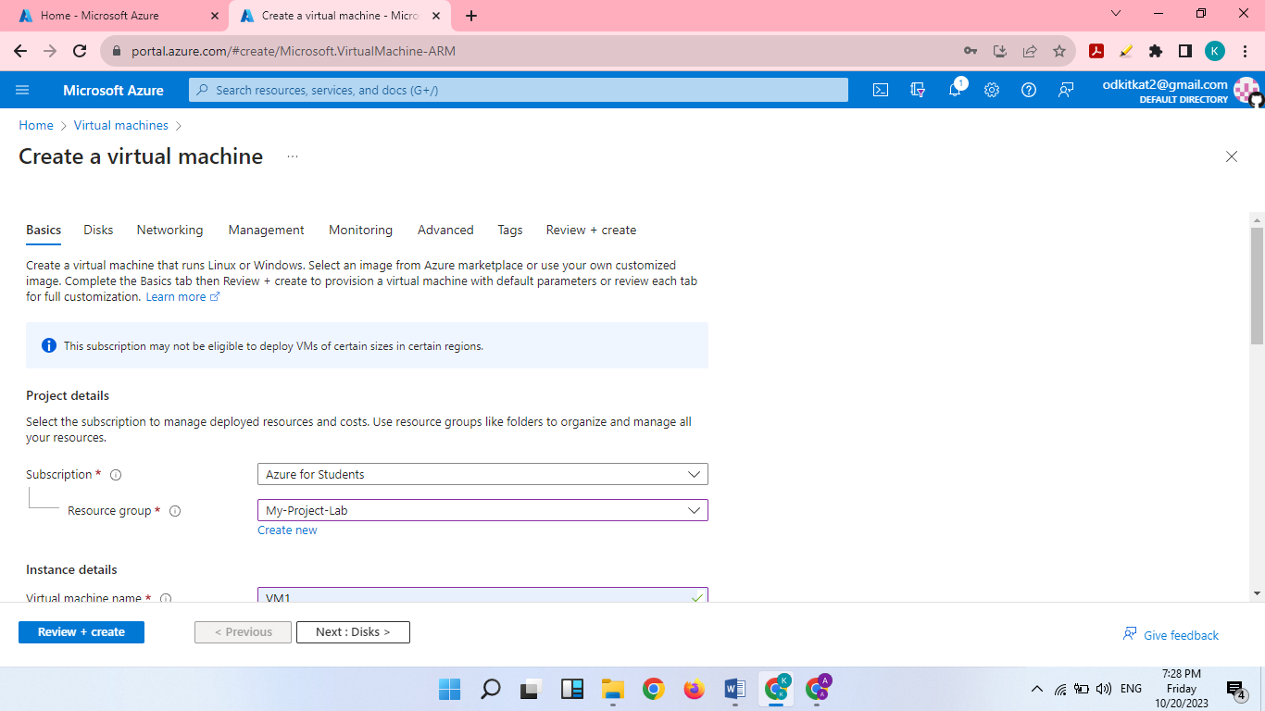

Create a virtual machine.

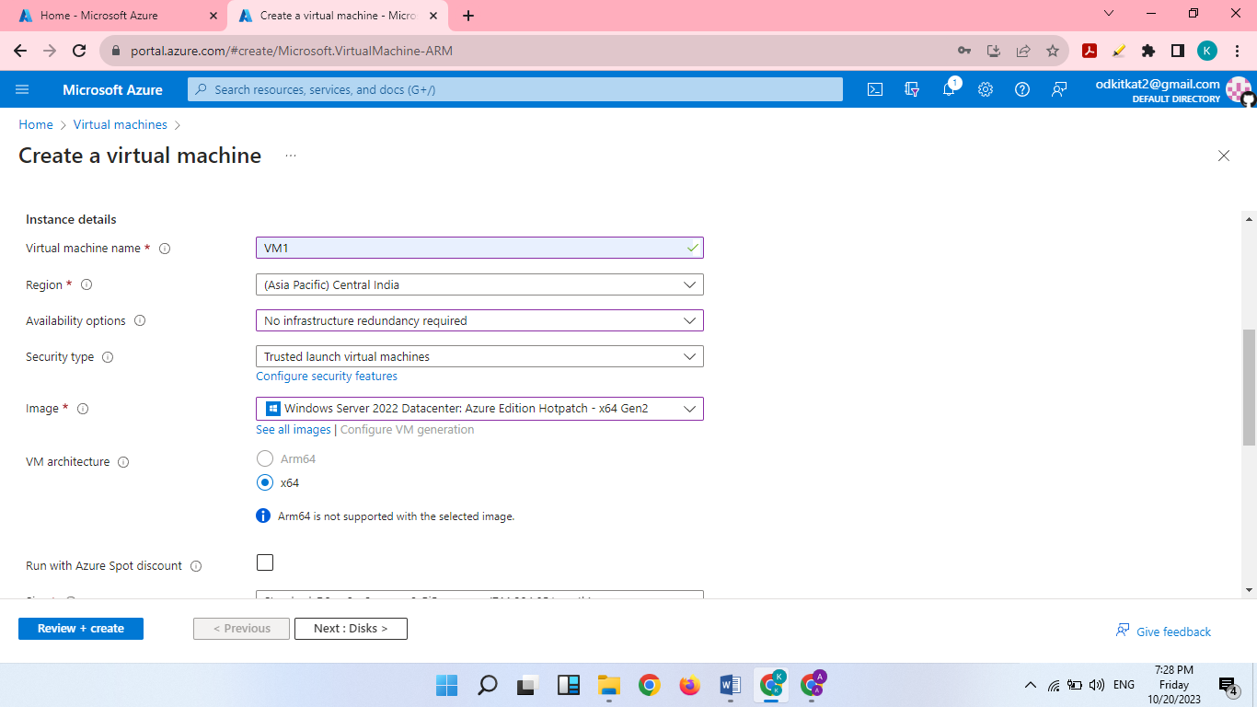

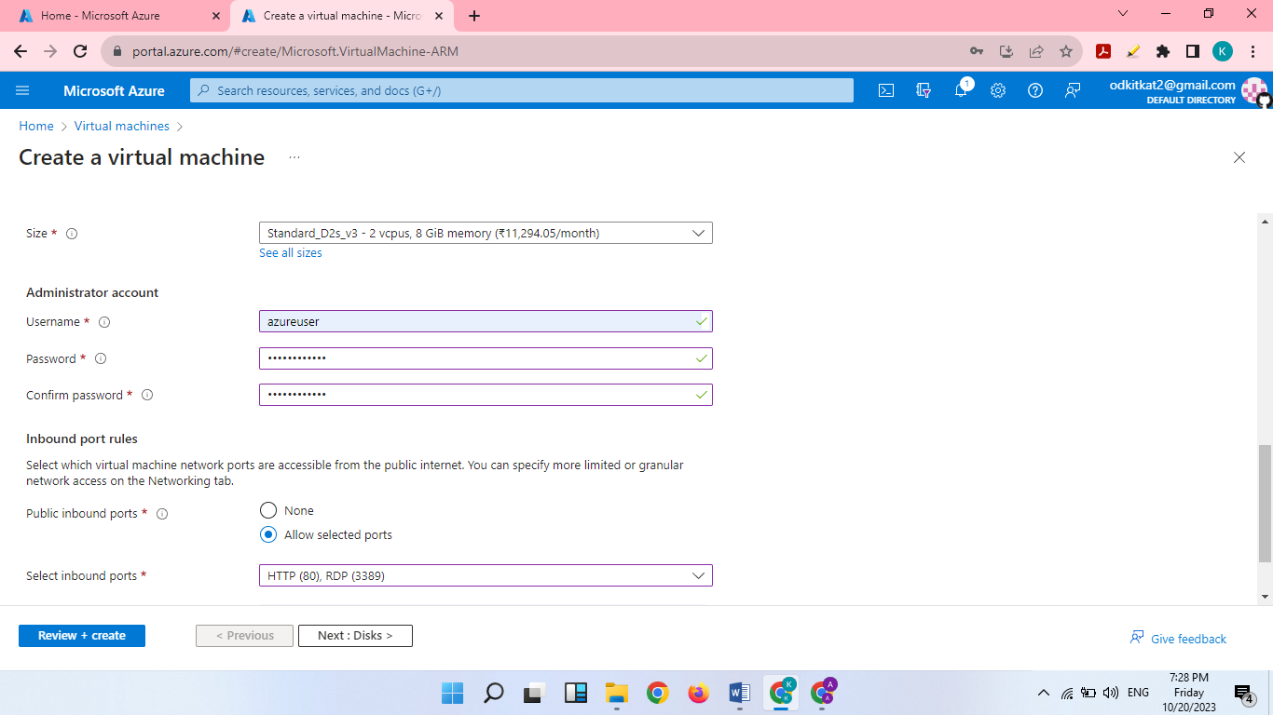

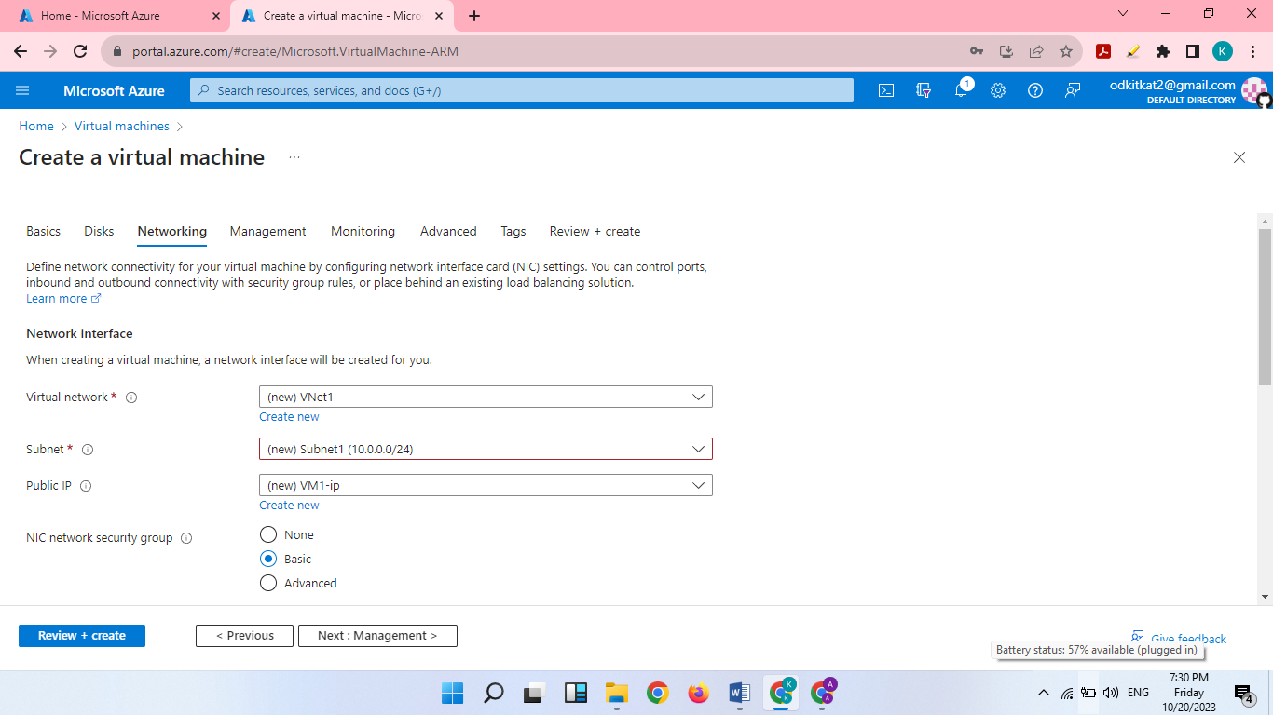

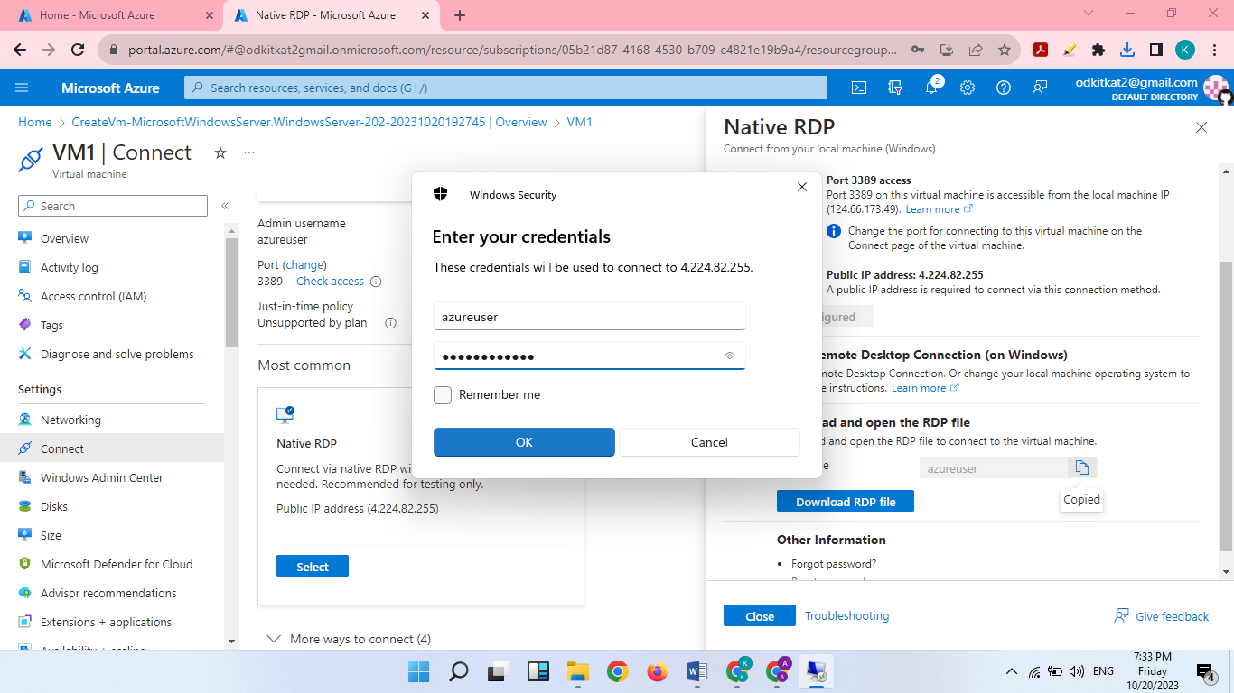

Connect virtual machine.

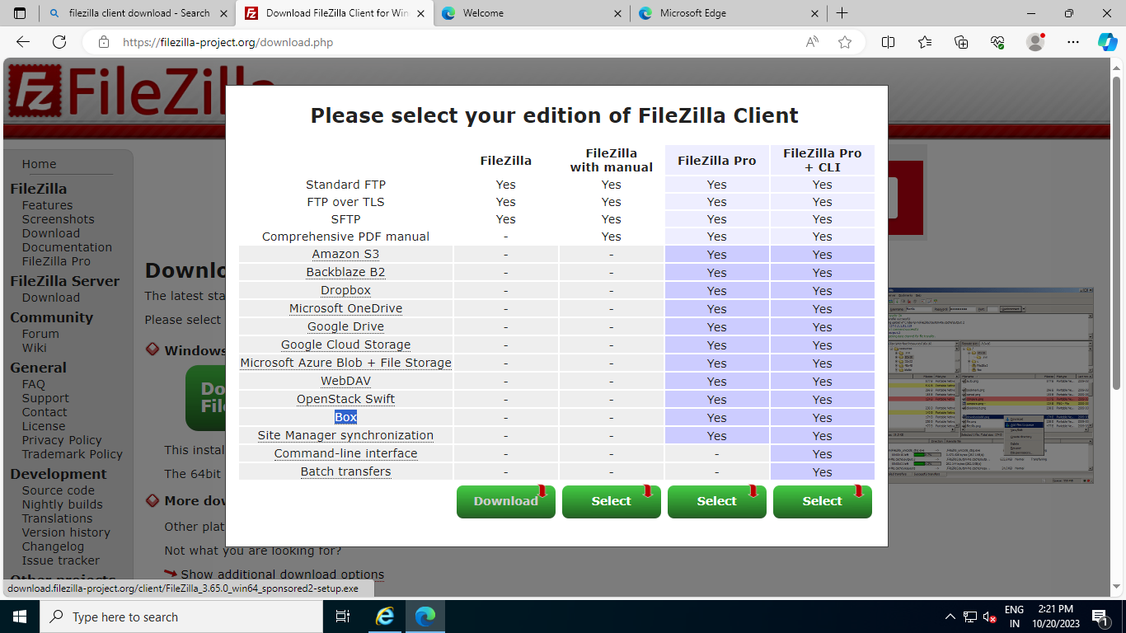

Download FileZilla.

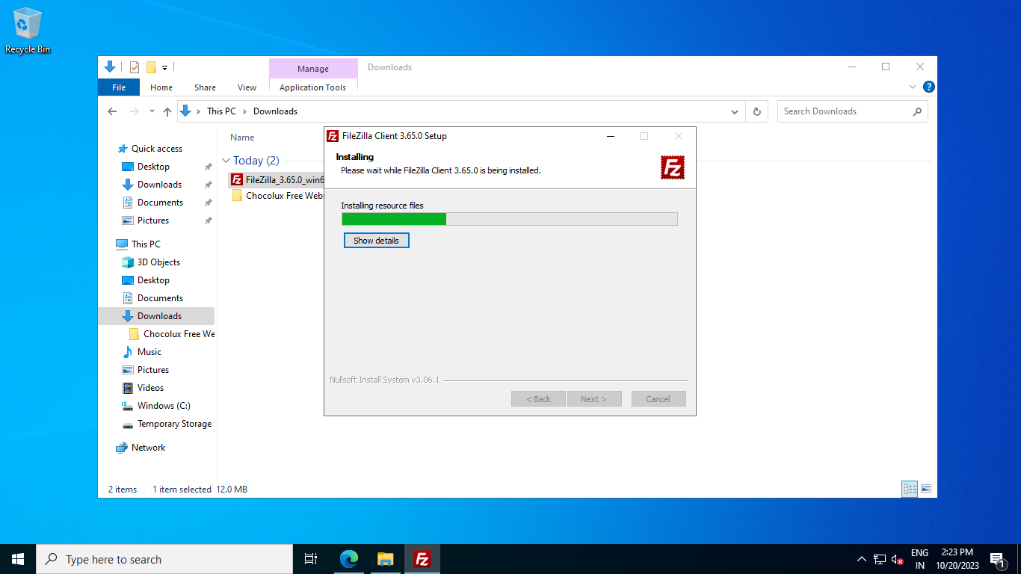

Install FileZilla.

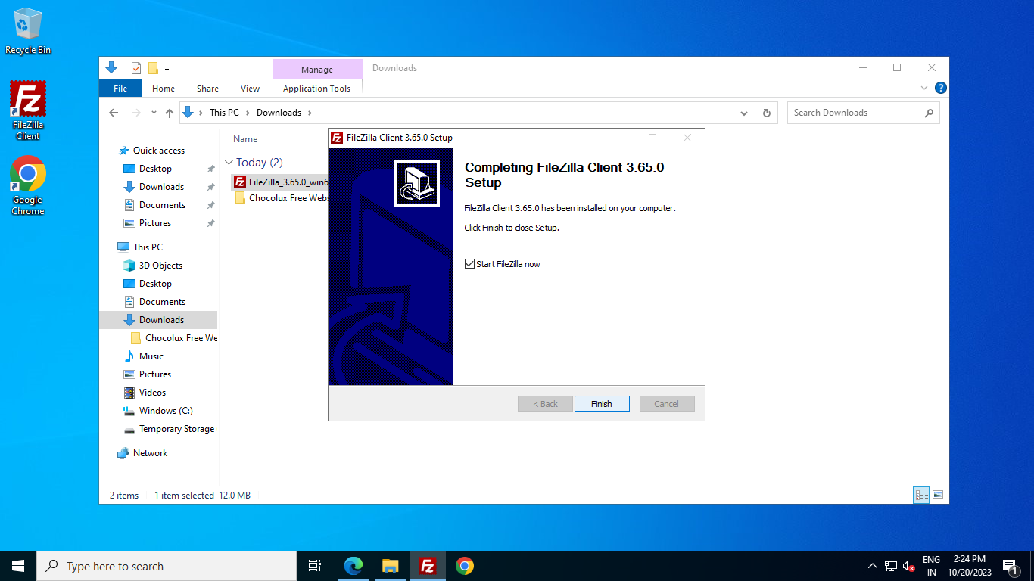

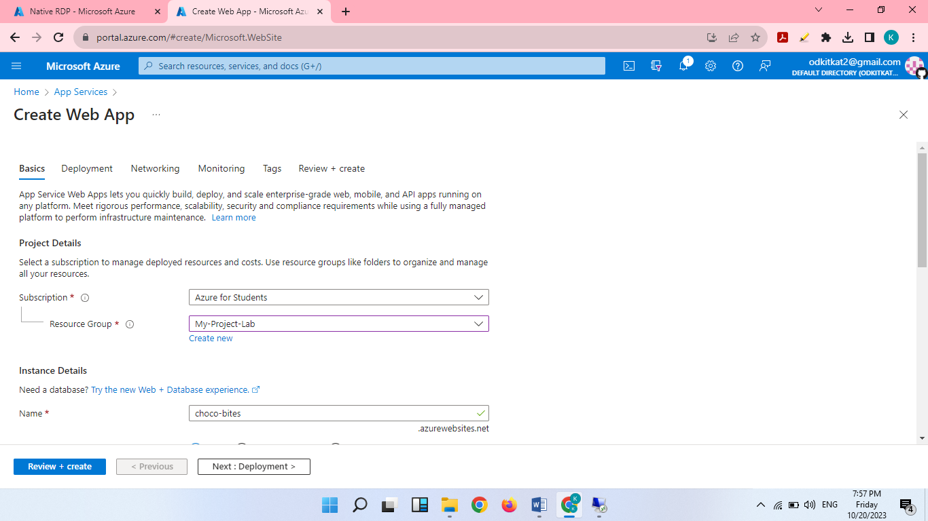

Create a Web App.

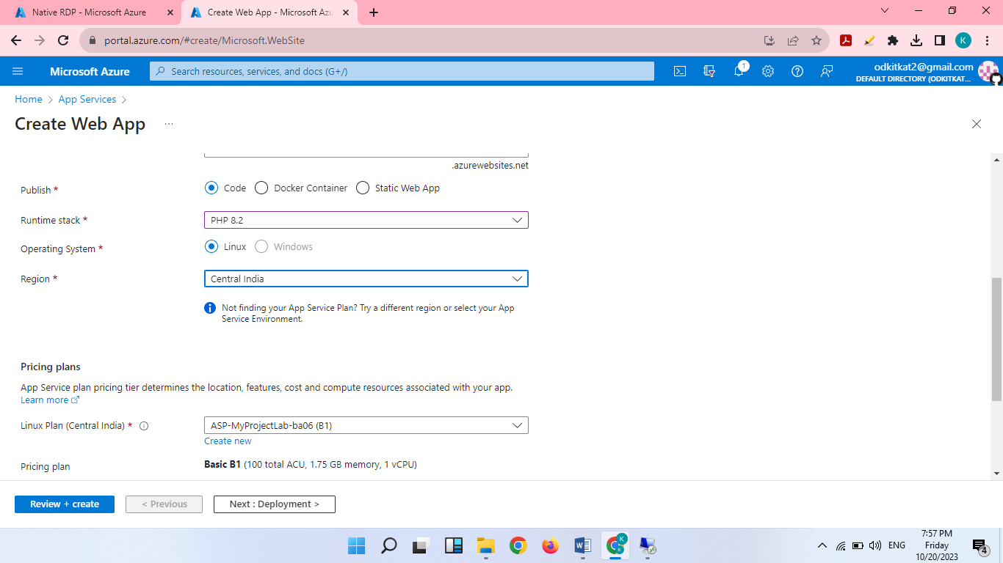

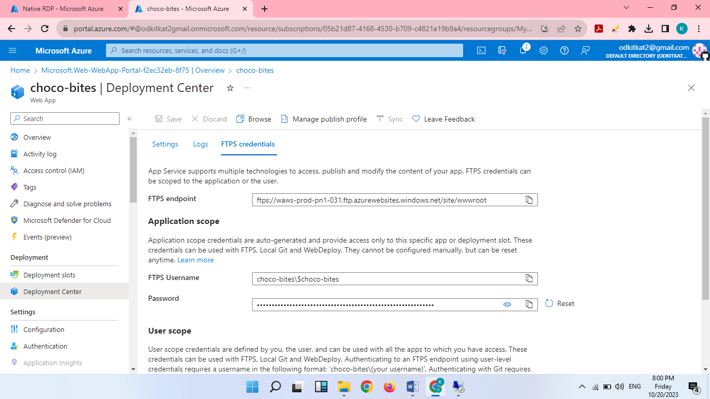

FTPS Credentials

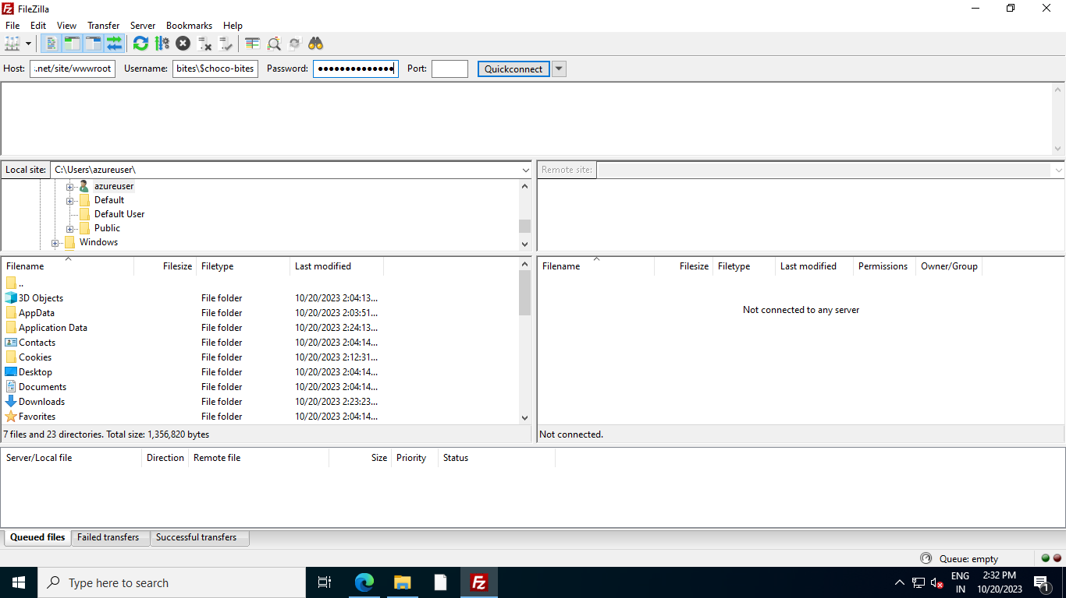

FTPS Credentials in FileZilla

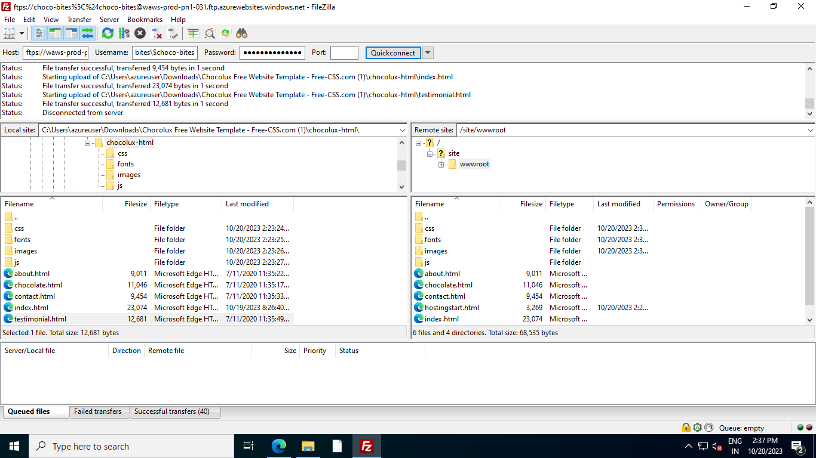

Transfer the file

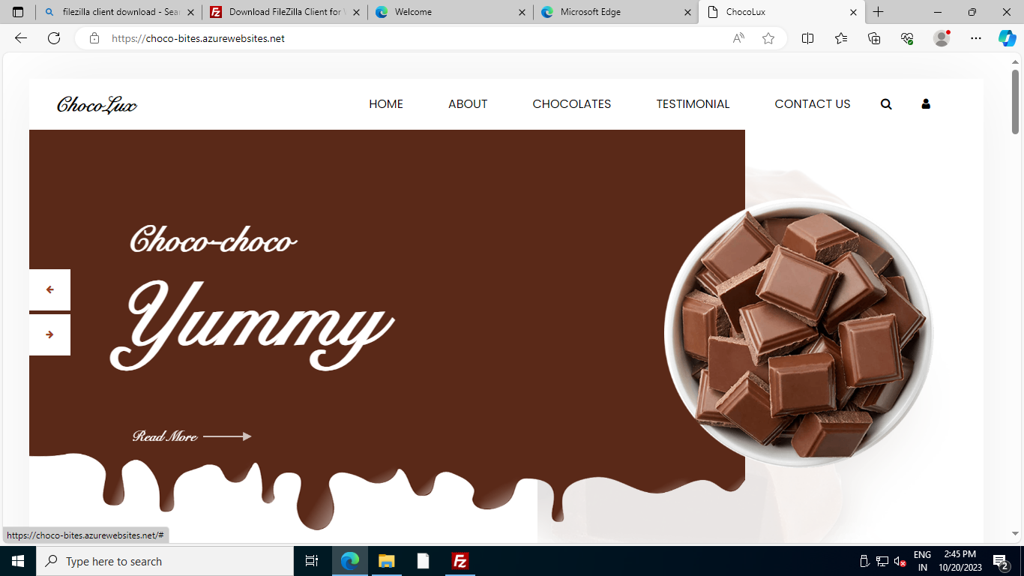

Website view in VM1

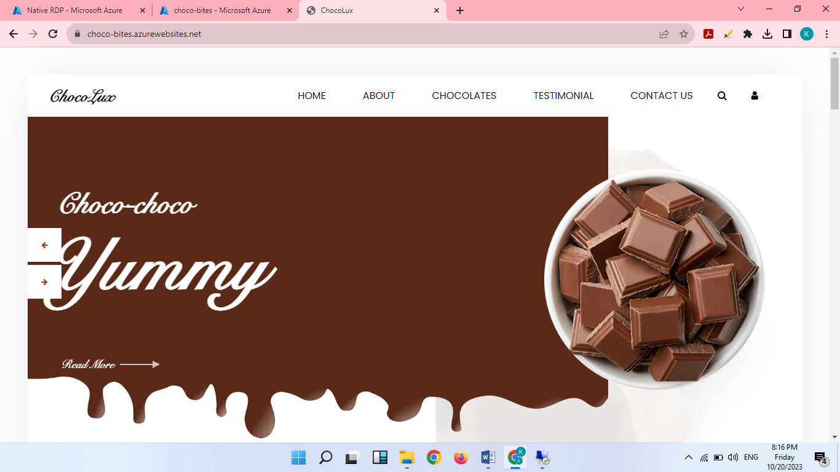

Website view in local machine

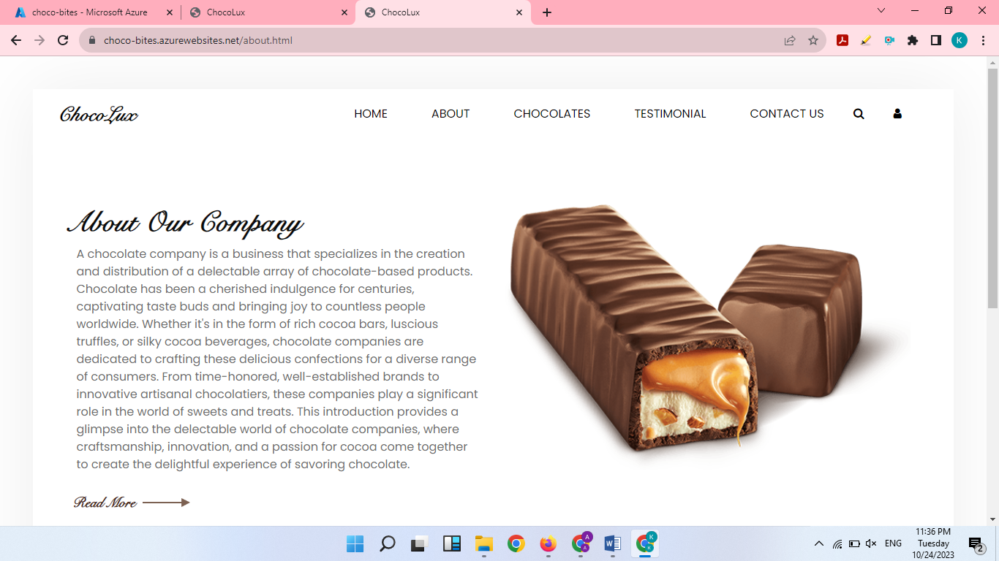

Working Website

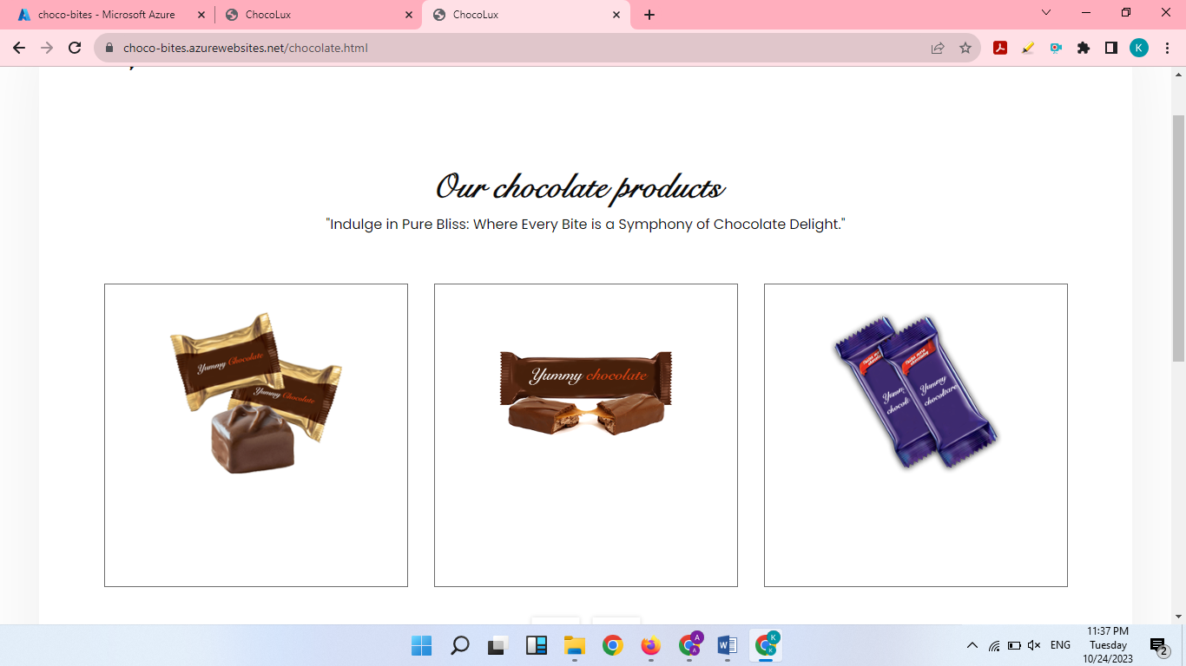

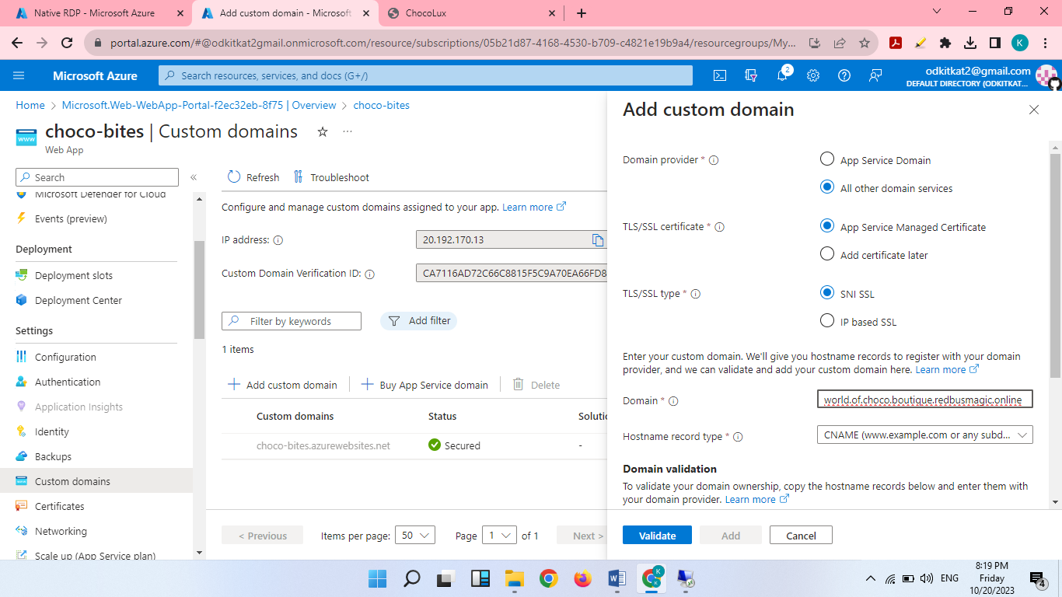

Create a custom domain

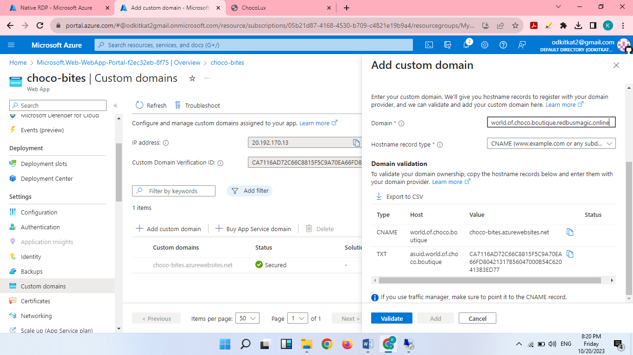

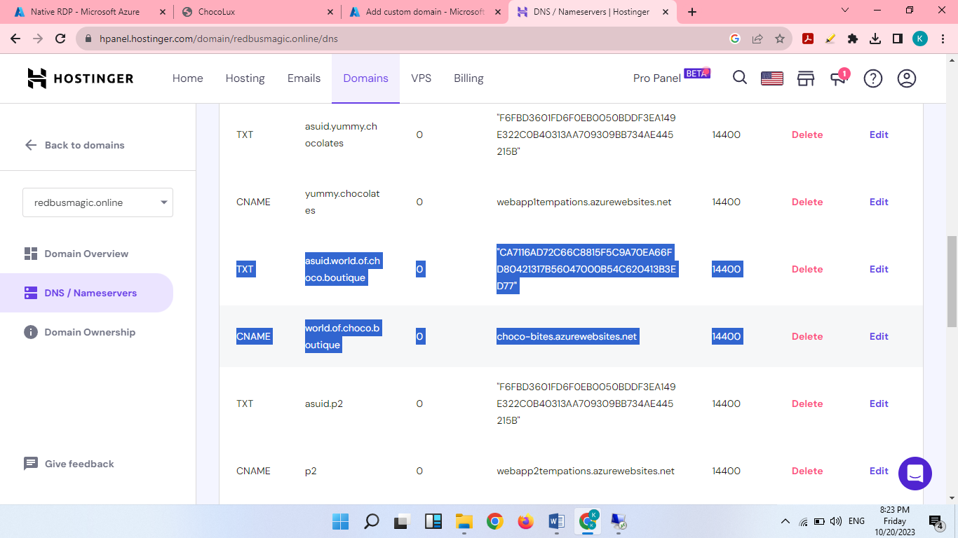

Added it in Hostinger

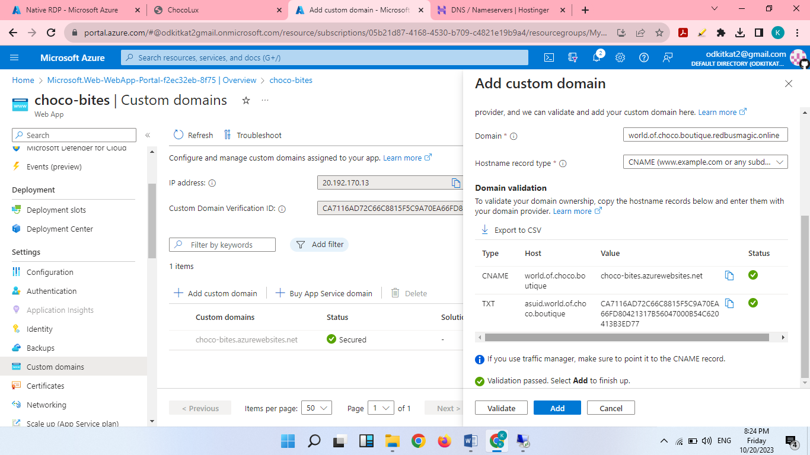

Validate the domain & Add

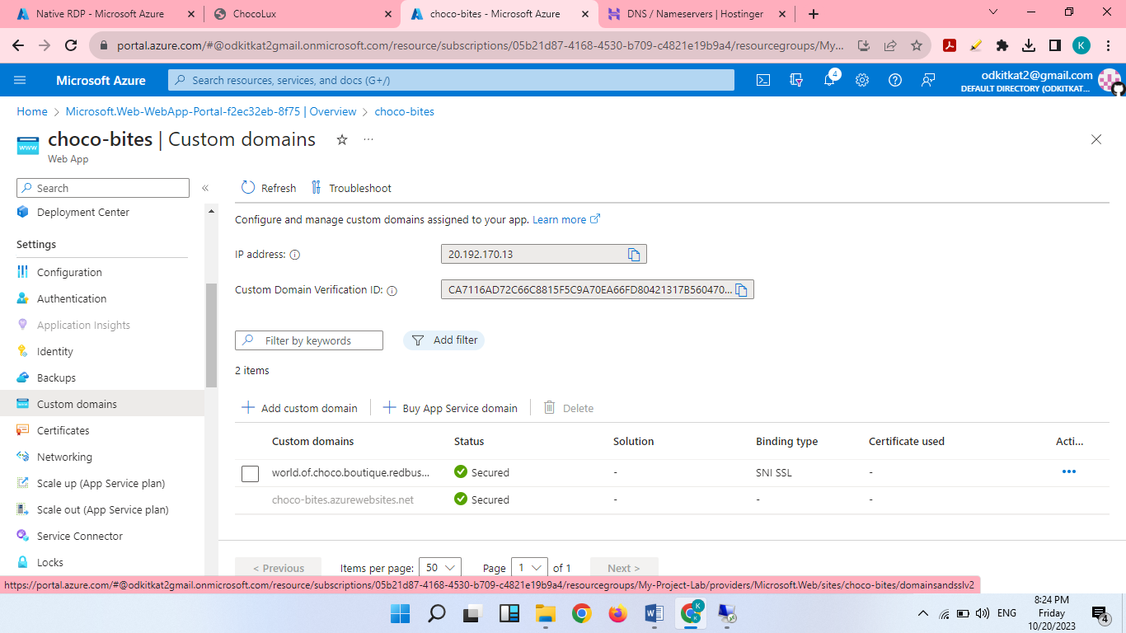

Domain with SSL

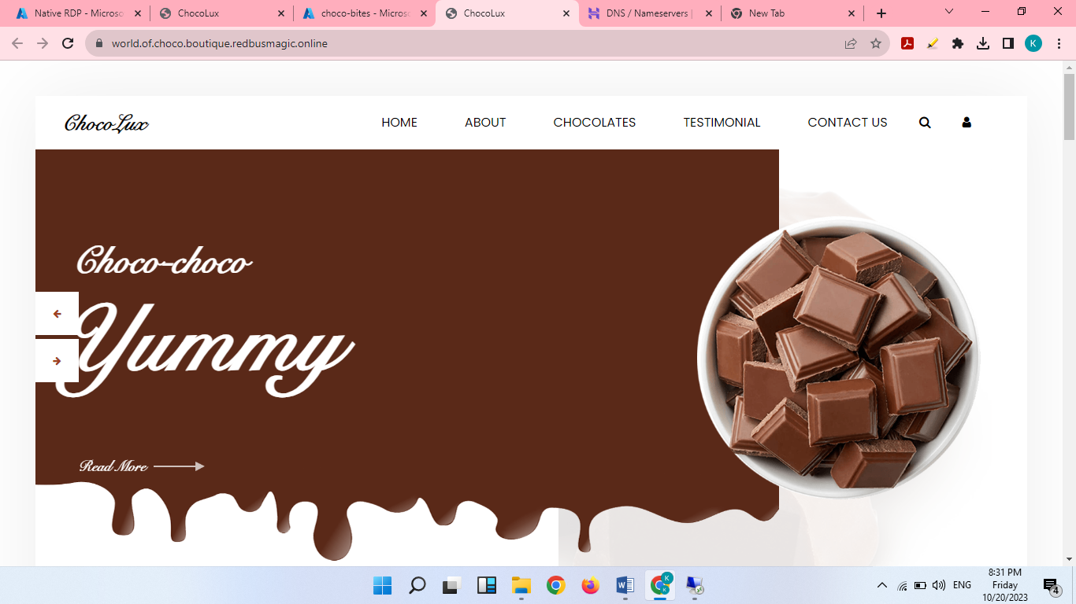

Viewing website with our own domain

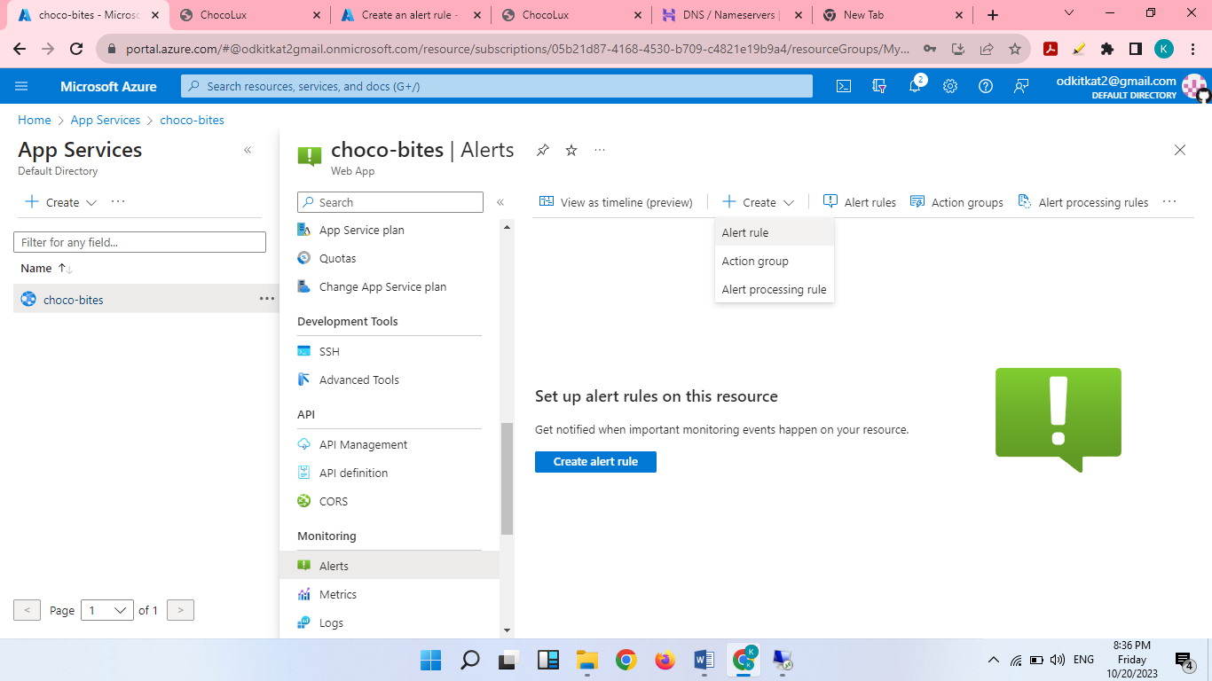

Creating an alert rule for web App

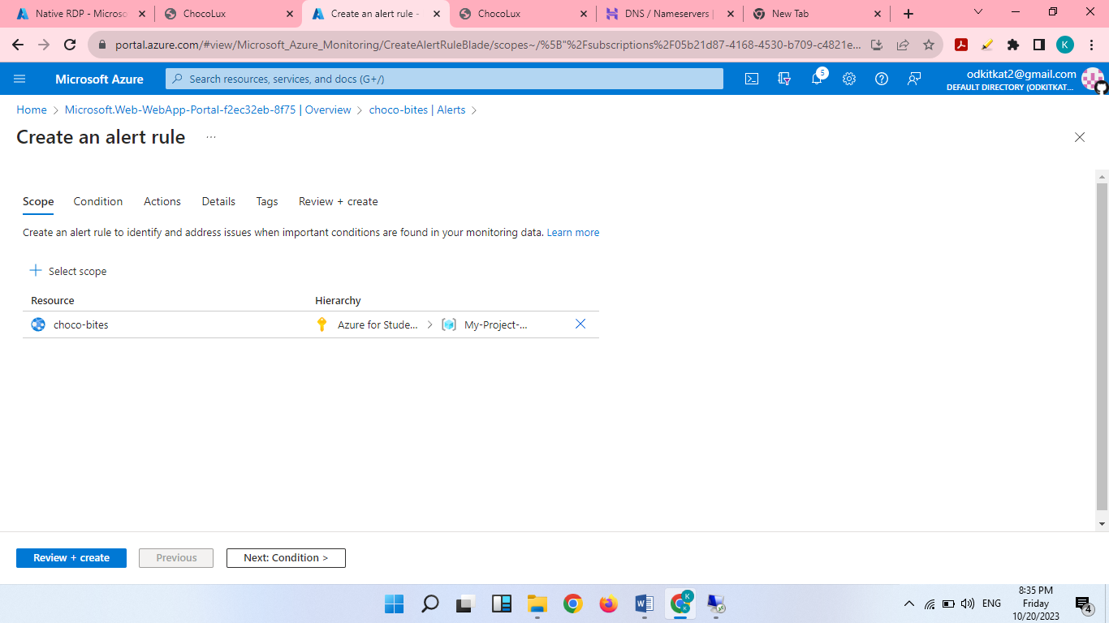

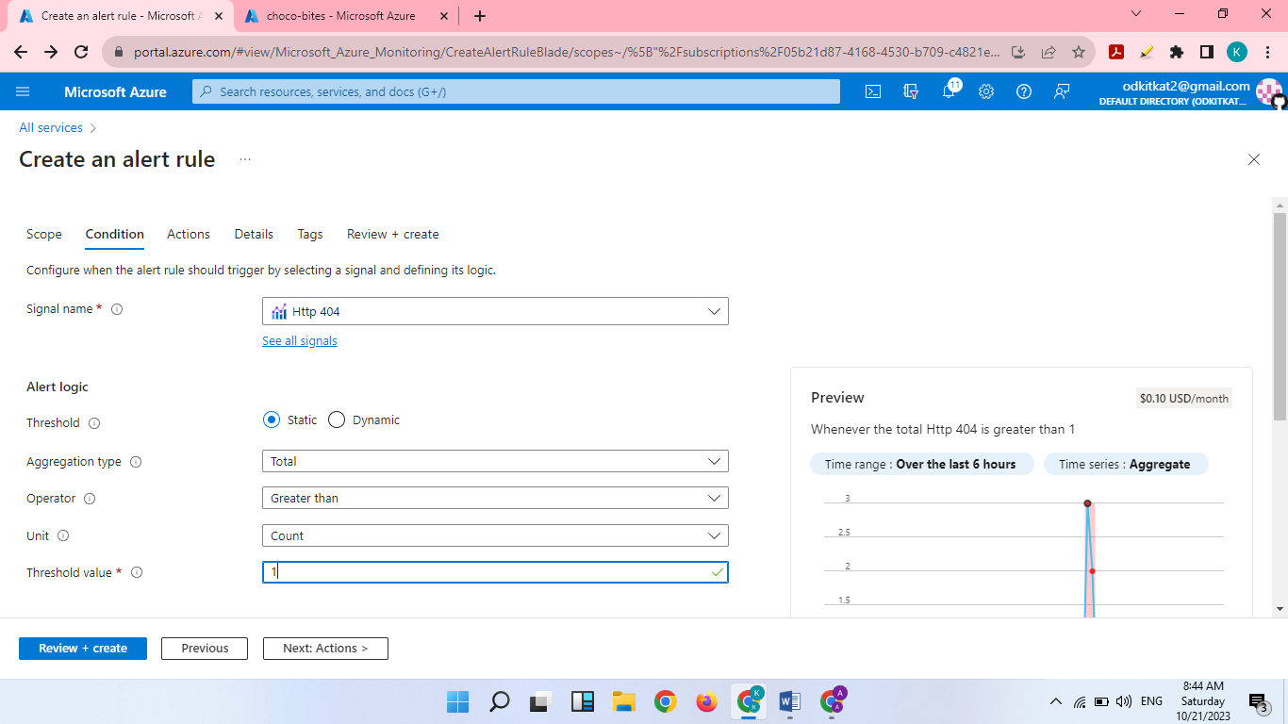

Identify the rule

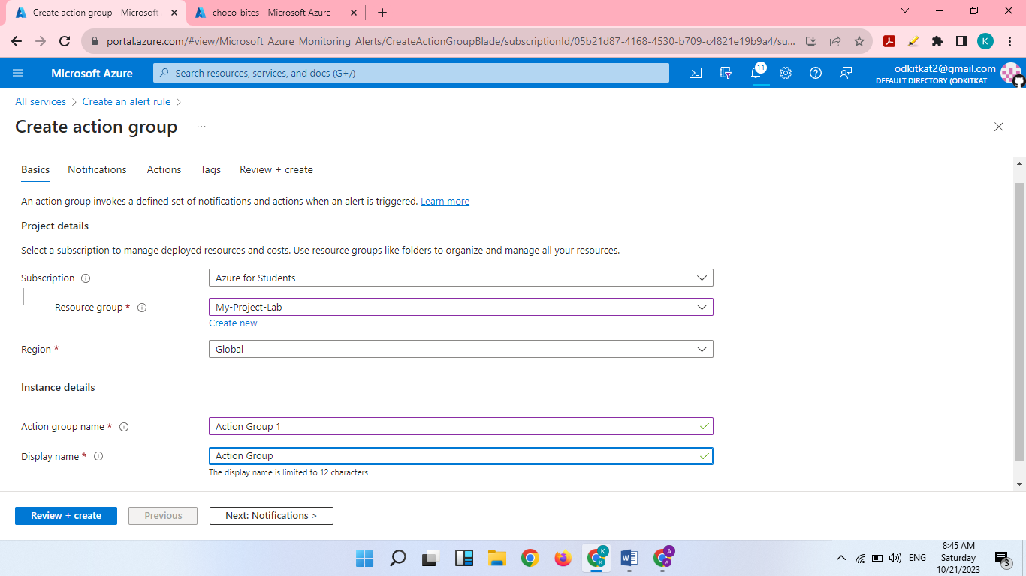

Create an action group

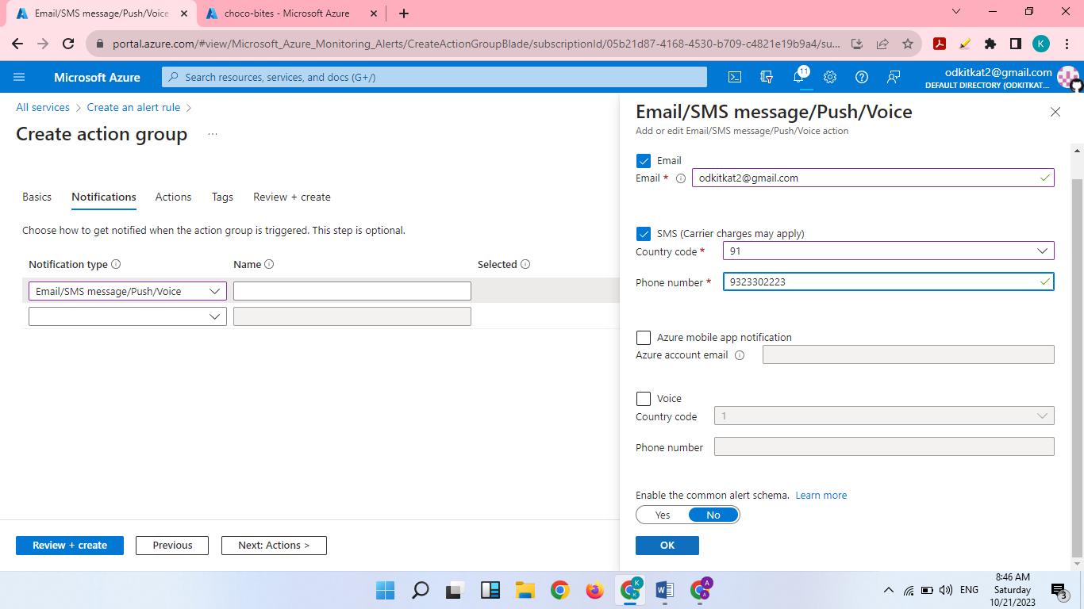

Giving email & phone number for notifications.

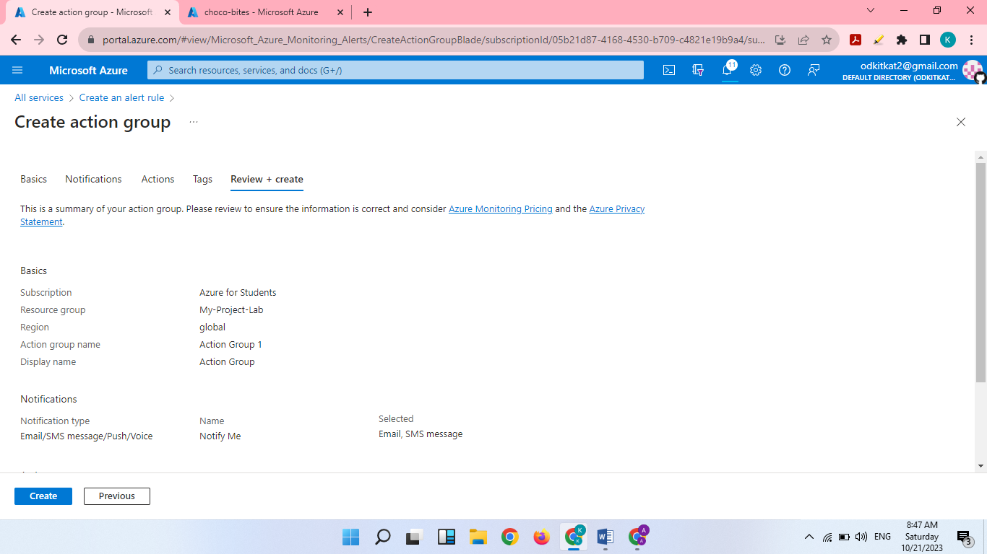

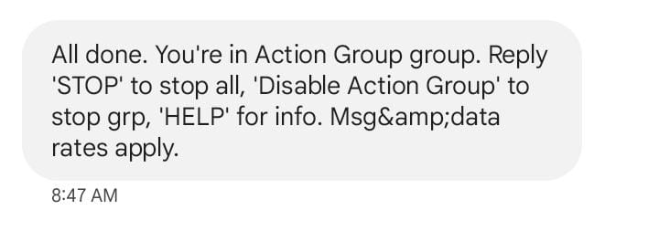

Registered phone number

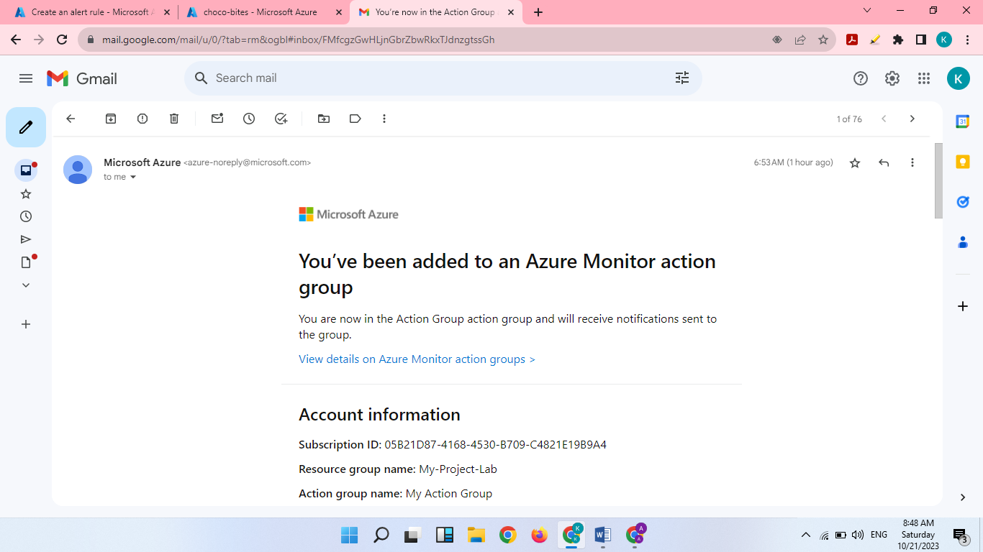

Registered email

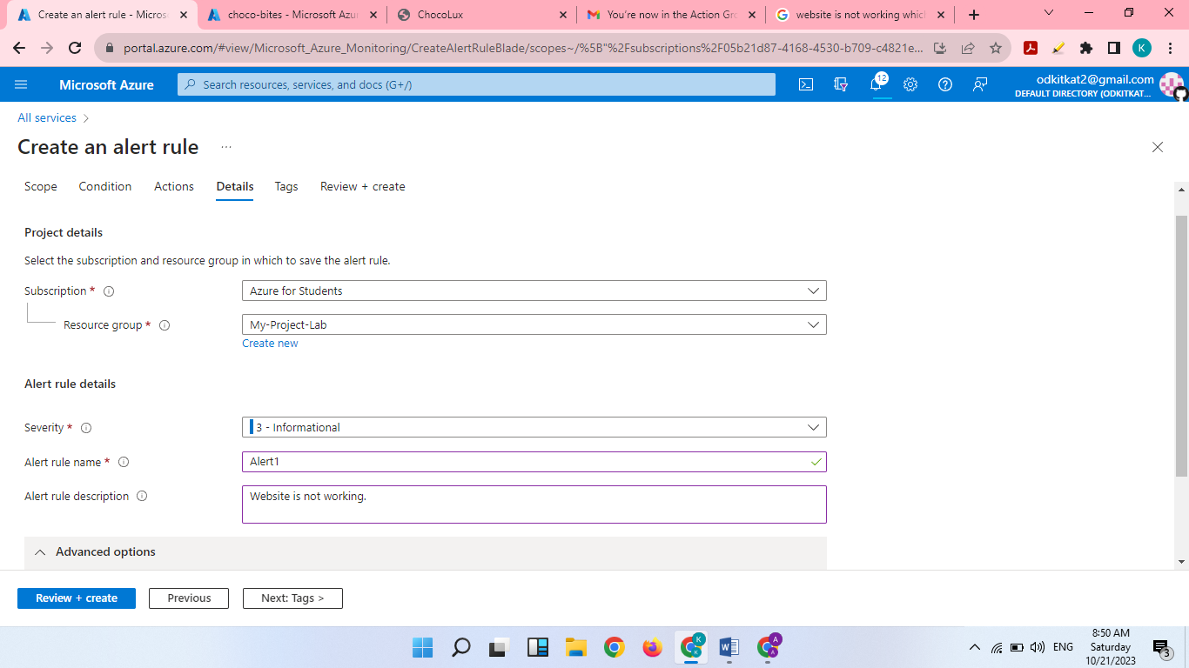

Create an alert rule for choco bites

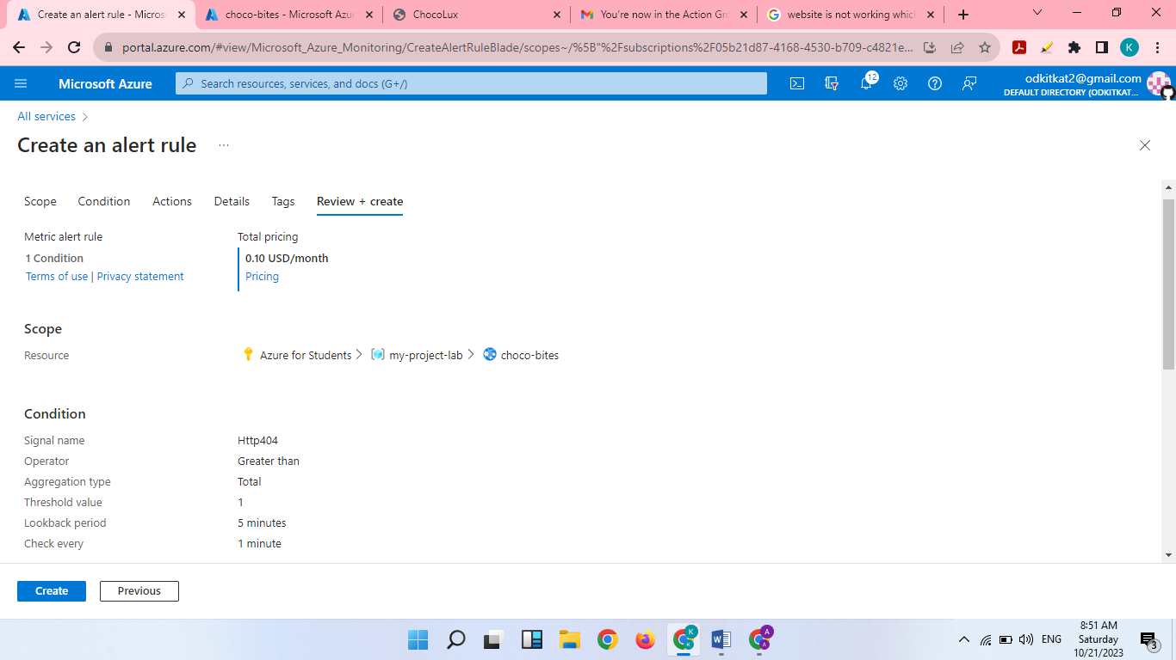

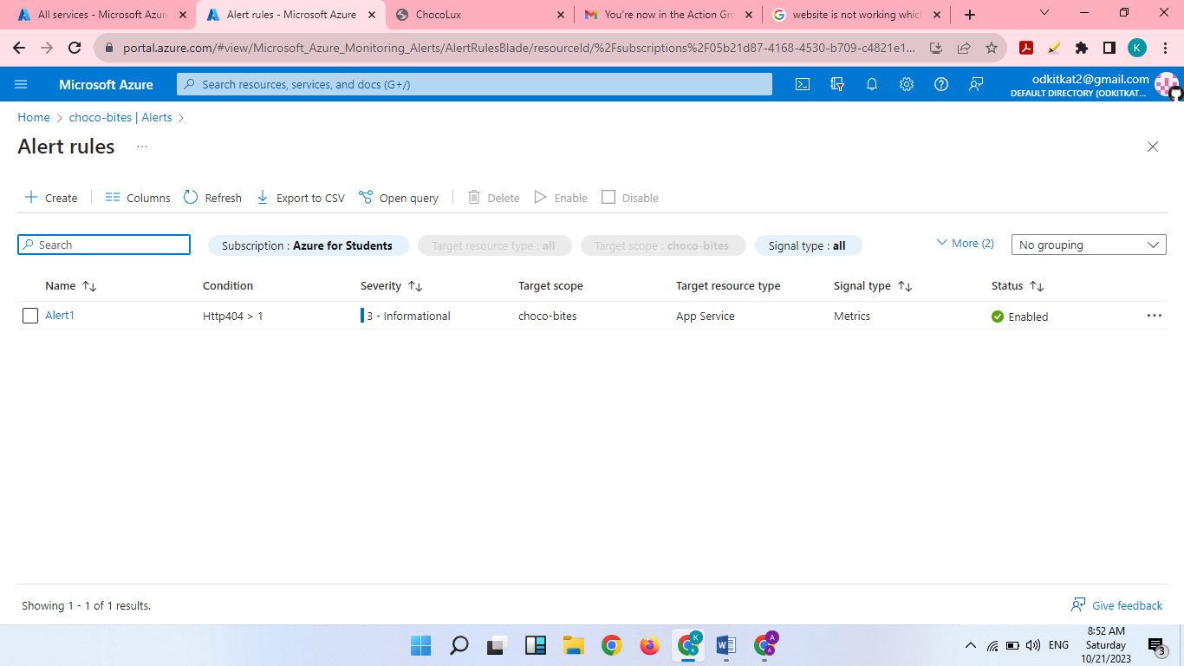

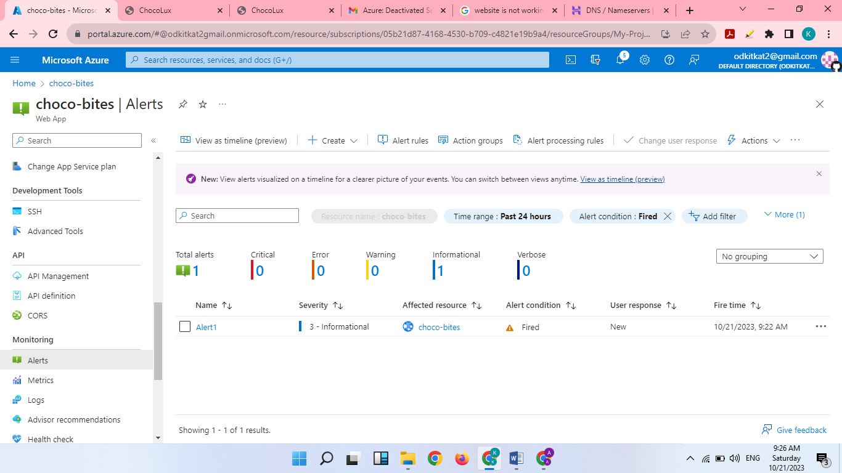

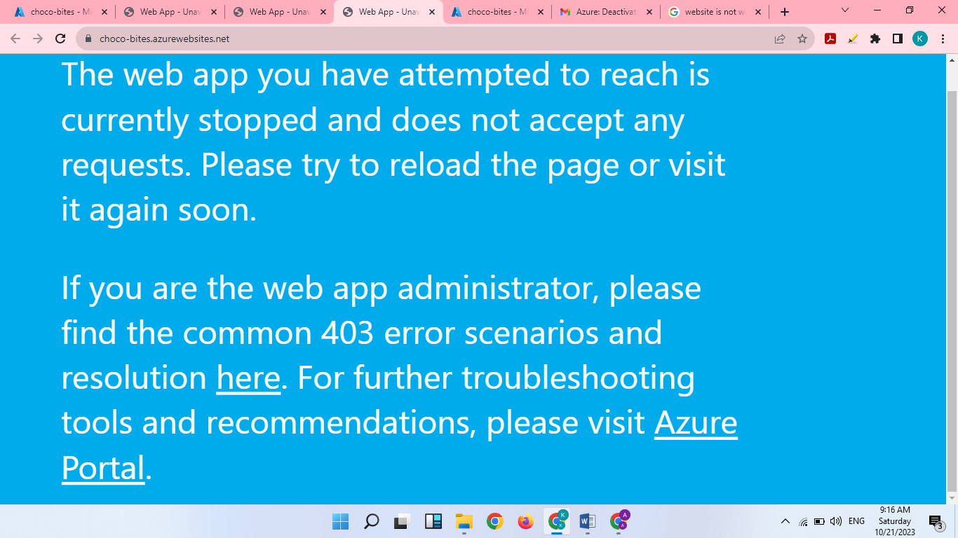

Access denied

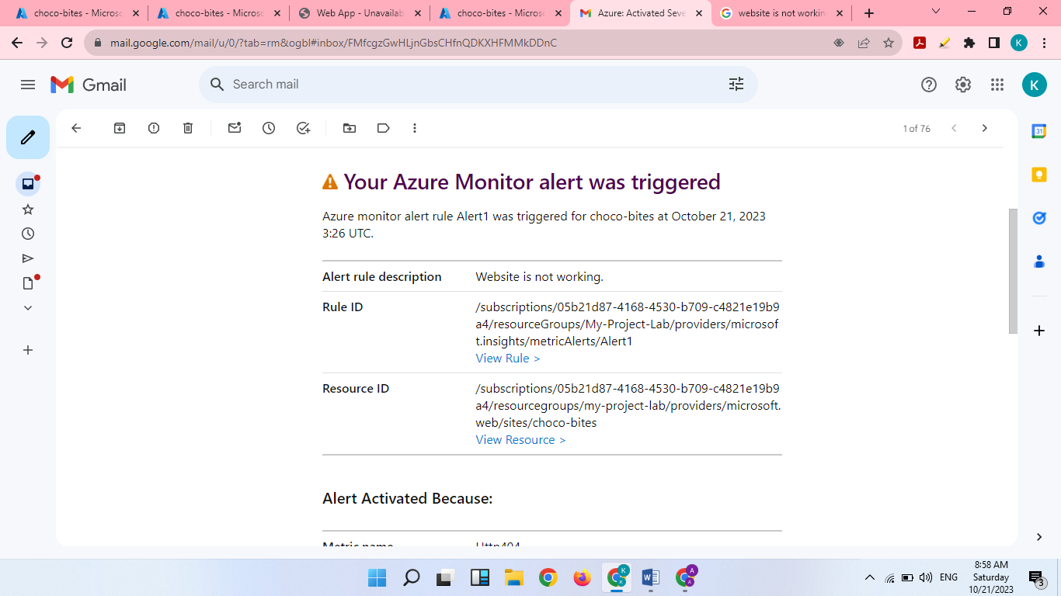

Email Received for error

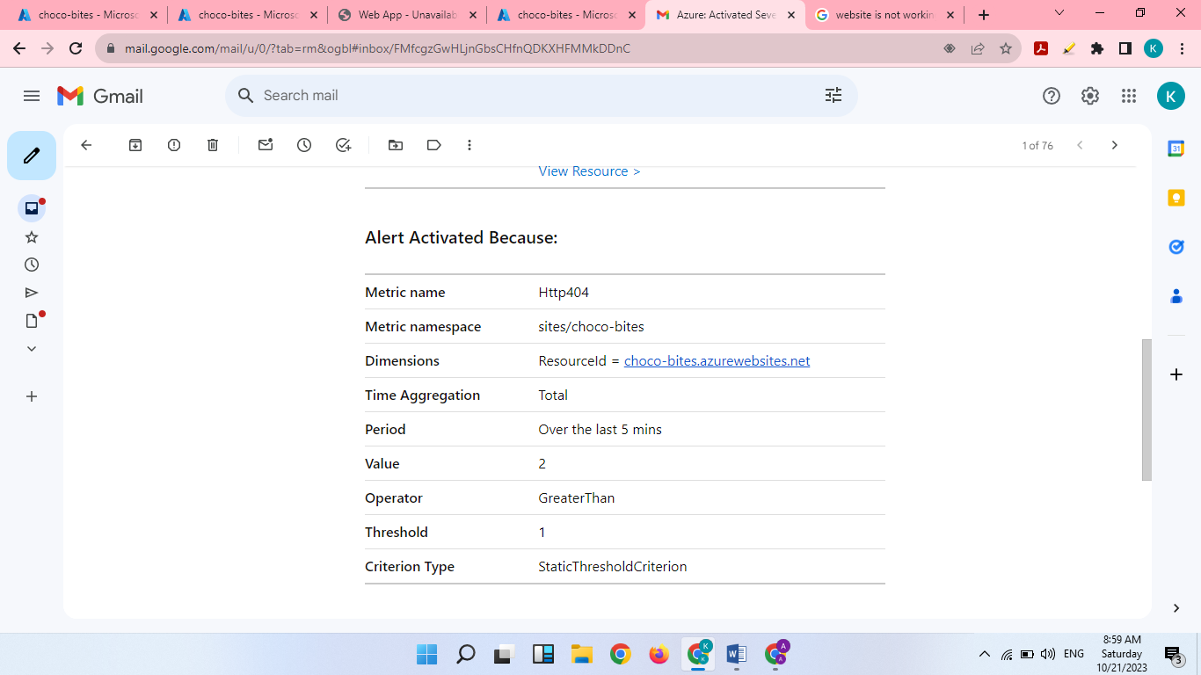

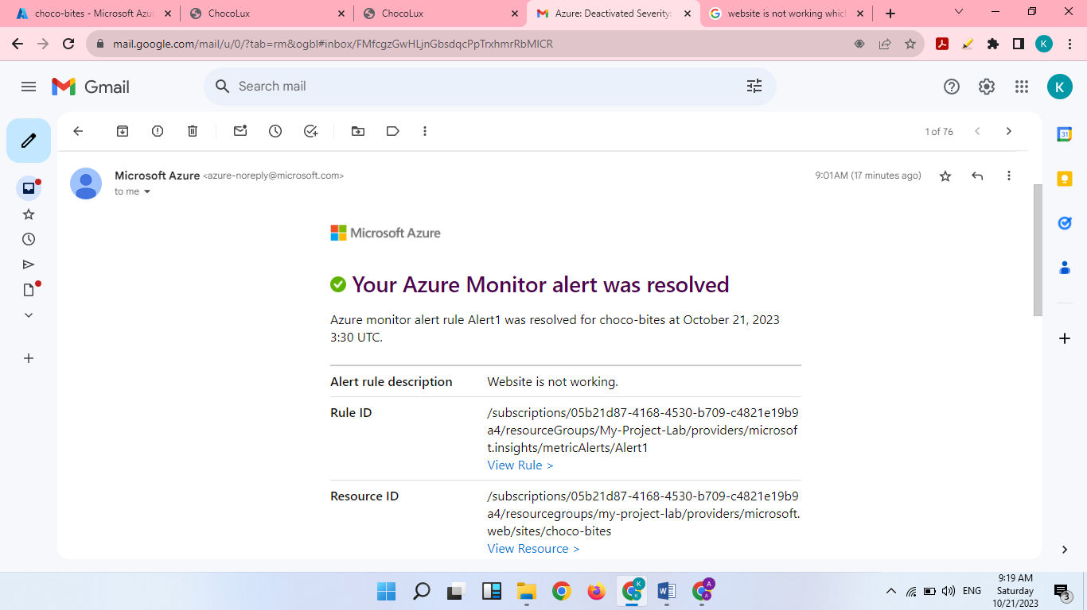

Email Received for error resolved

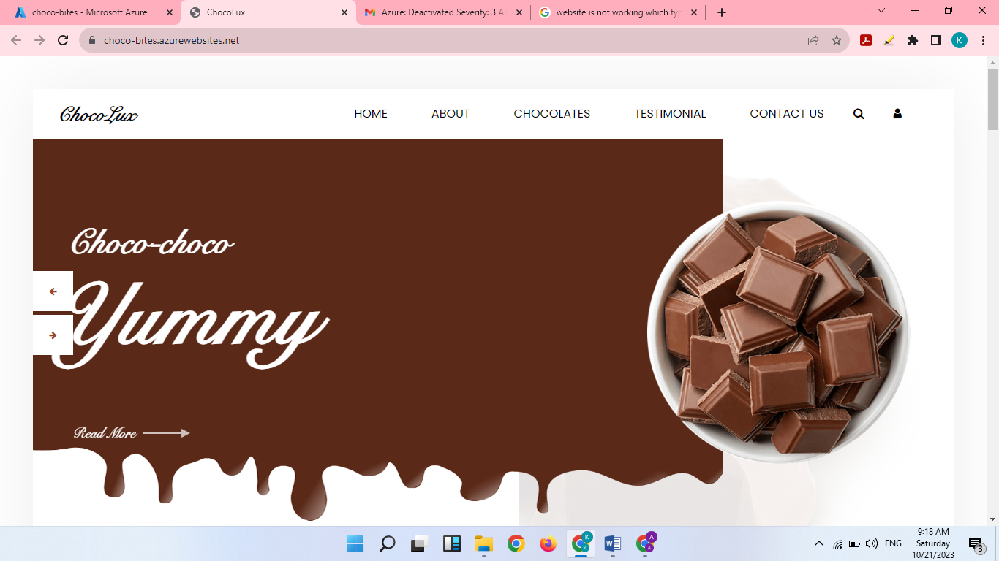

We can view website now

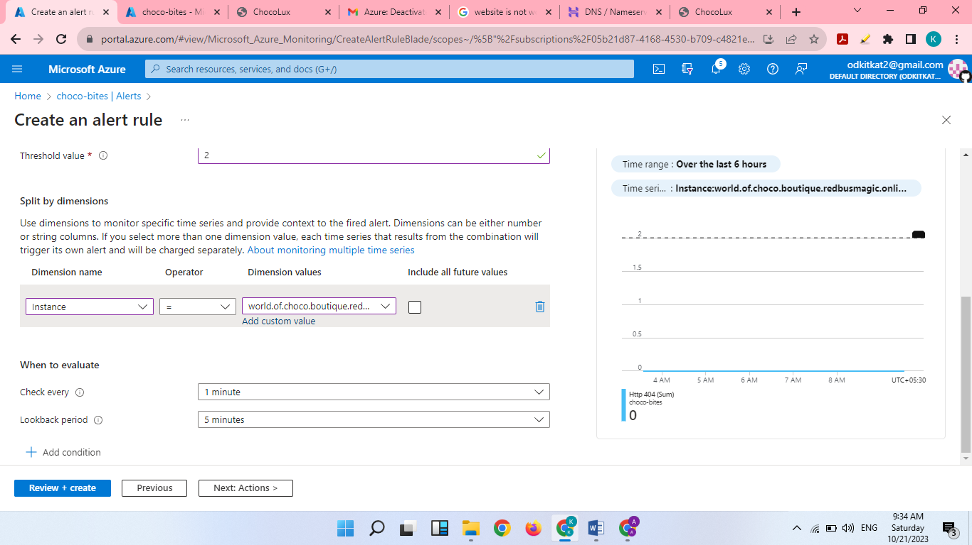

Create an alert rule for worldofchocoboutique

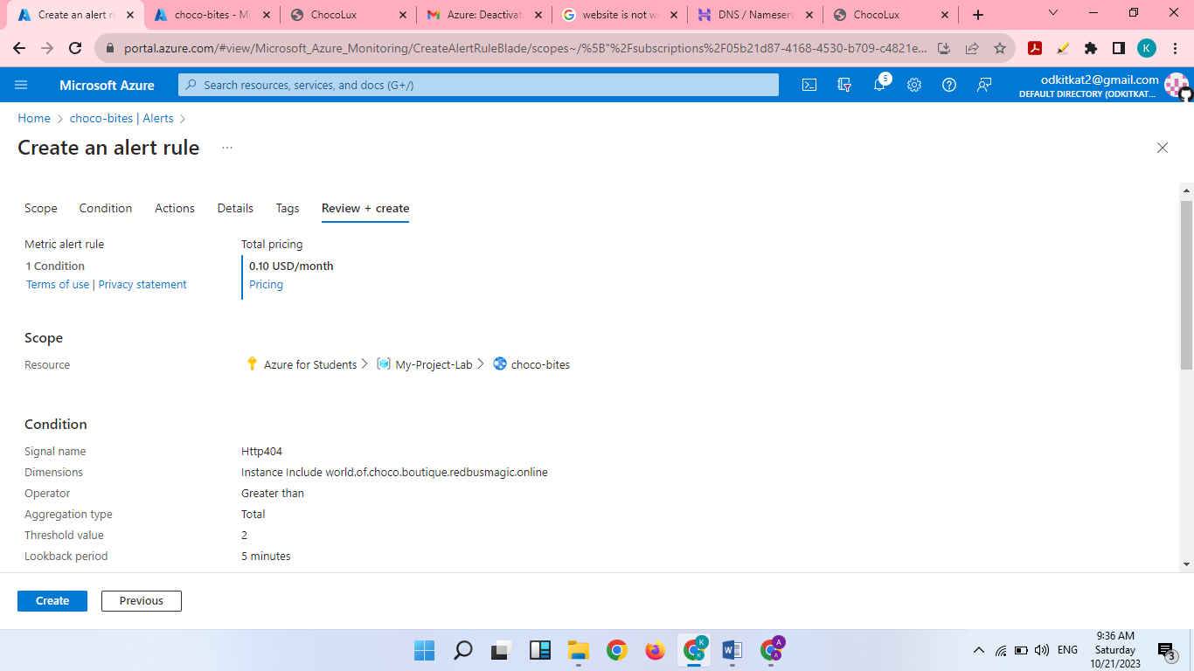

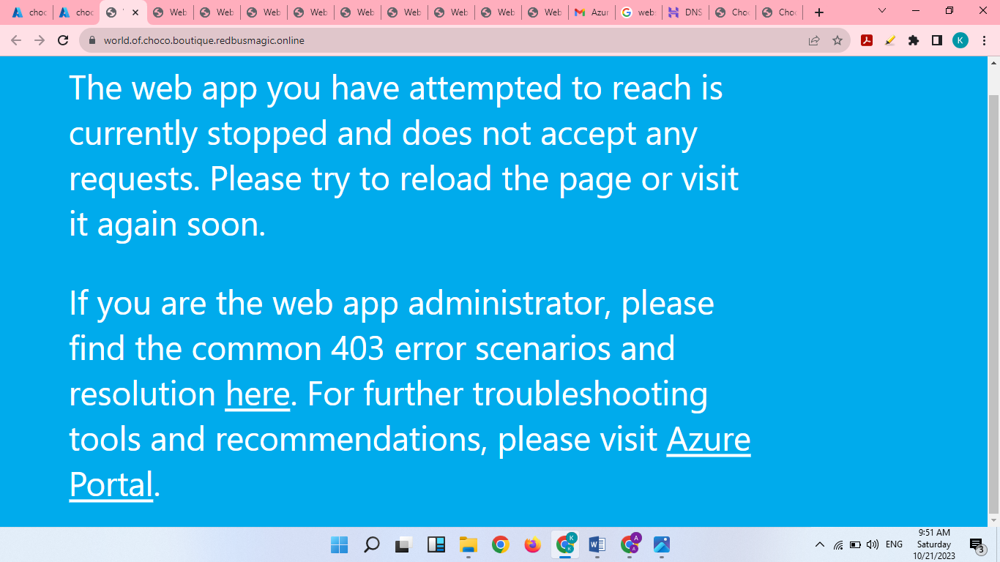

Access Denied

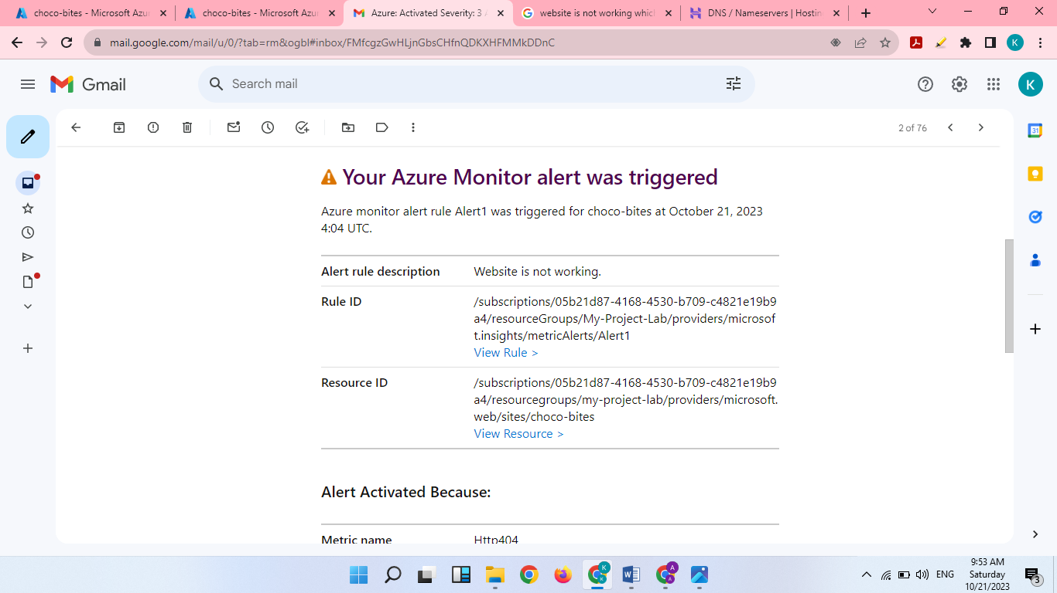

Email Received for error

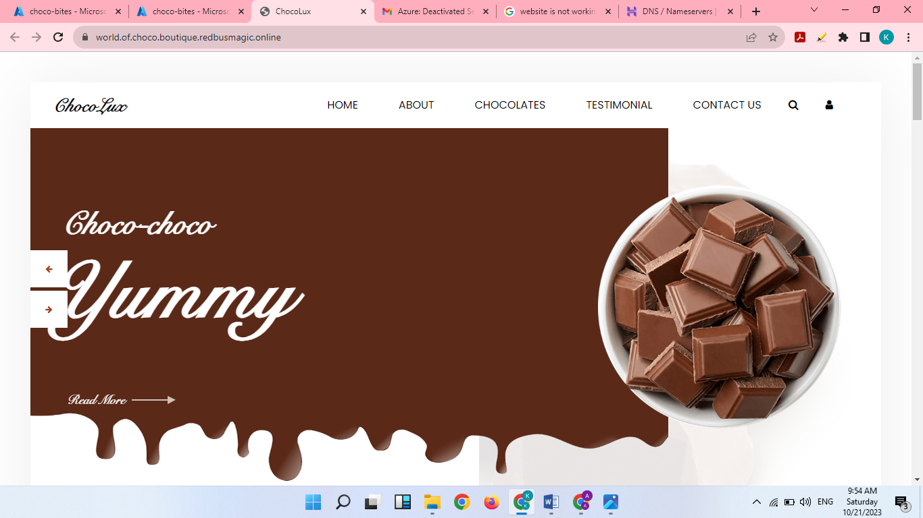

We can view website now

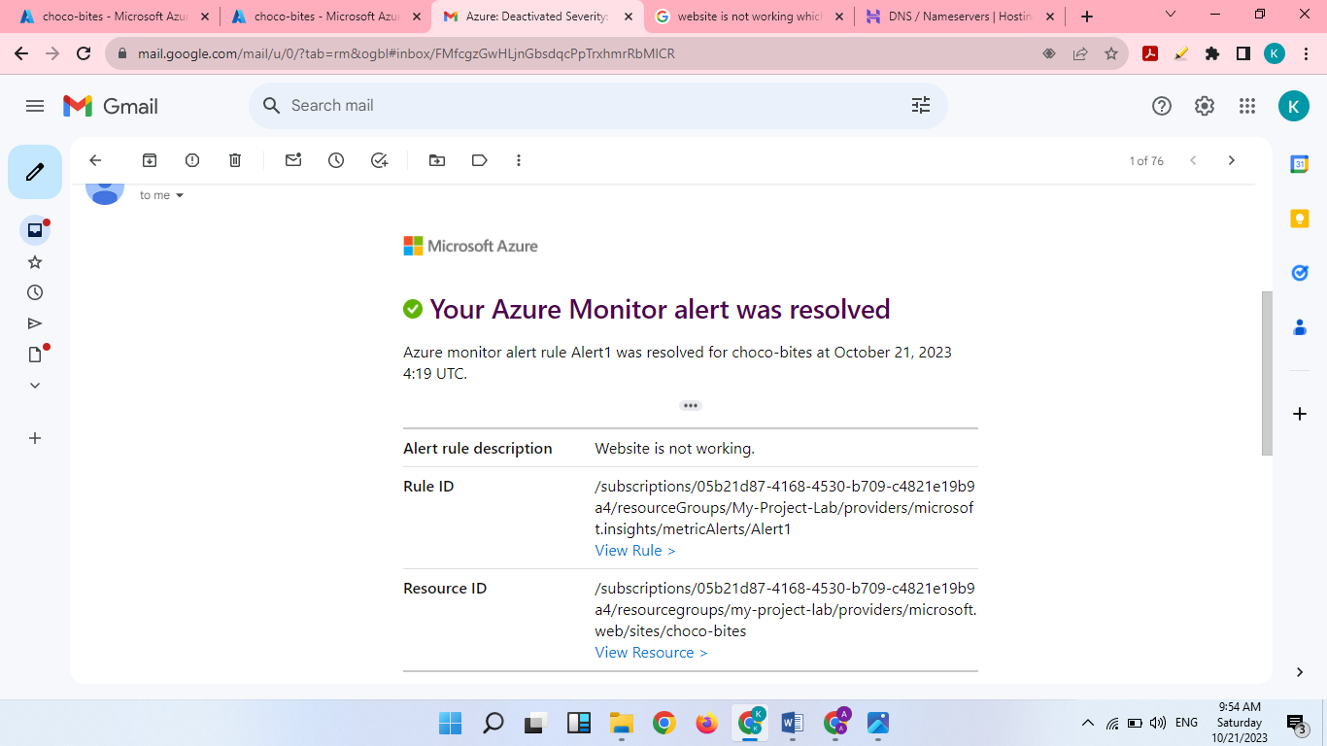

Email Received for error resolved

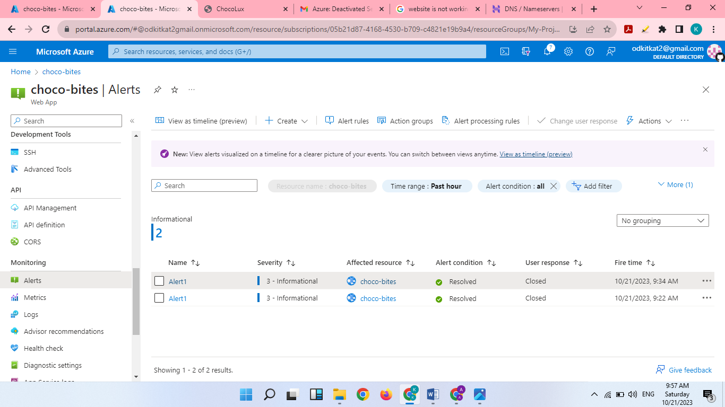

Error Solved

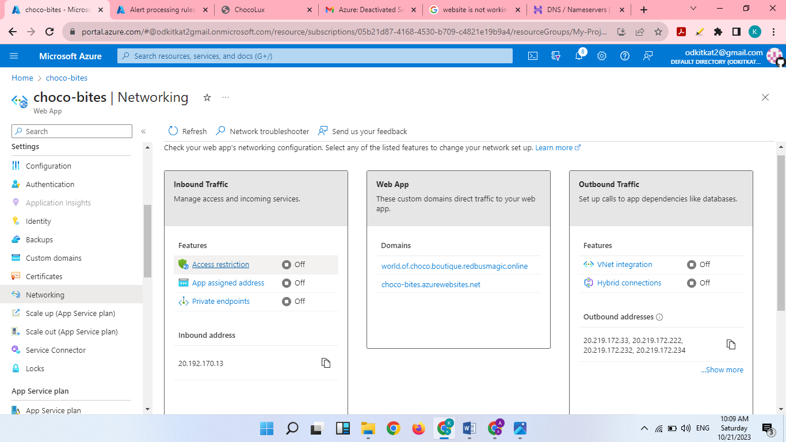

Access restriction ON

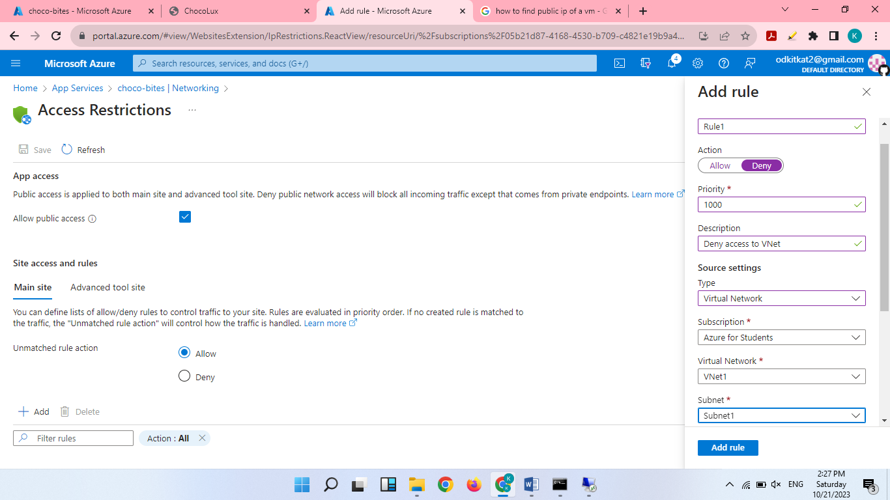

Add Rule to deny access to VM1

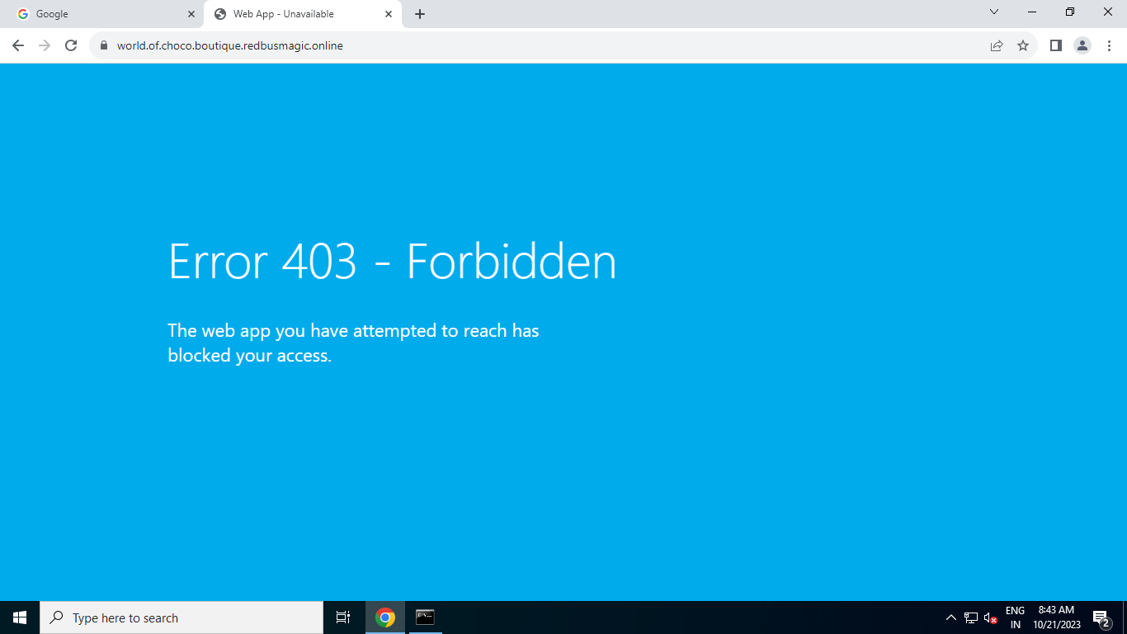

Access Denied in VM1

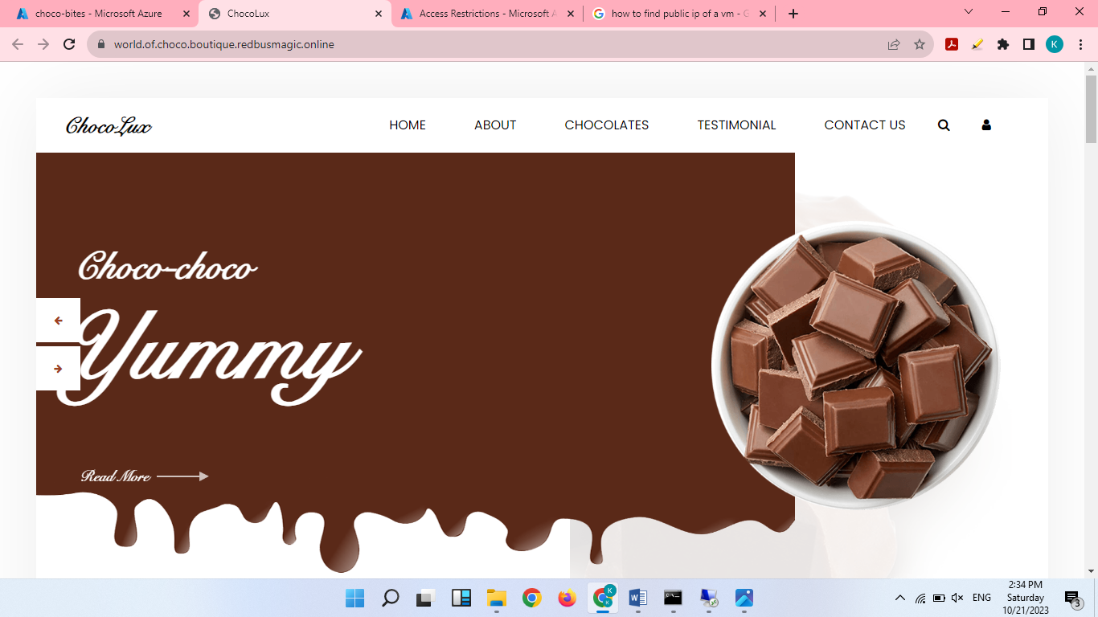

But able to view in Local Machine

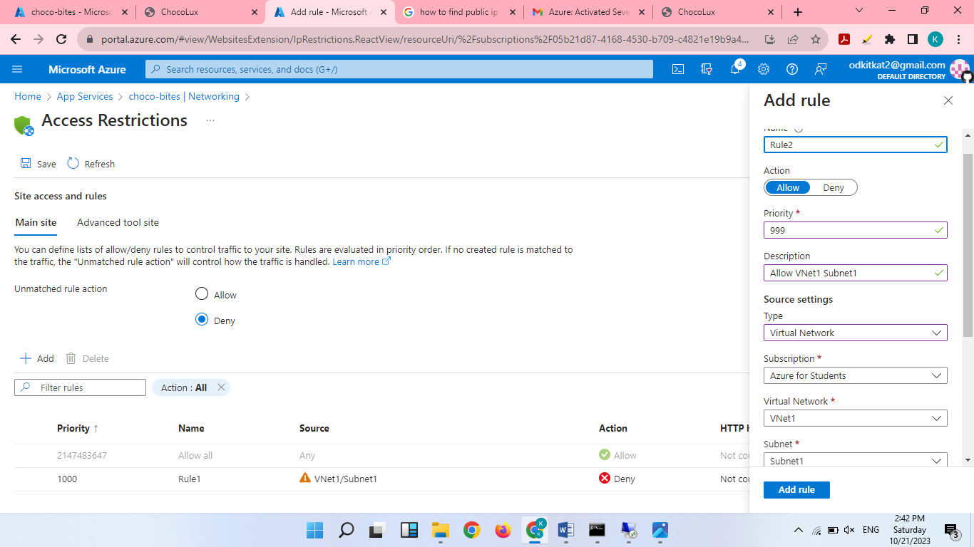

Add Rule to allow access to VM1

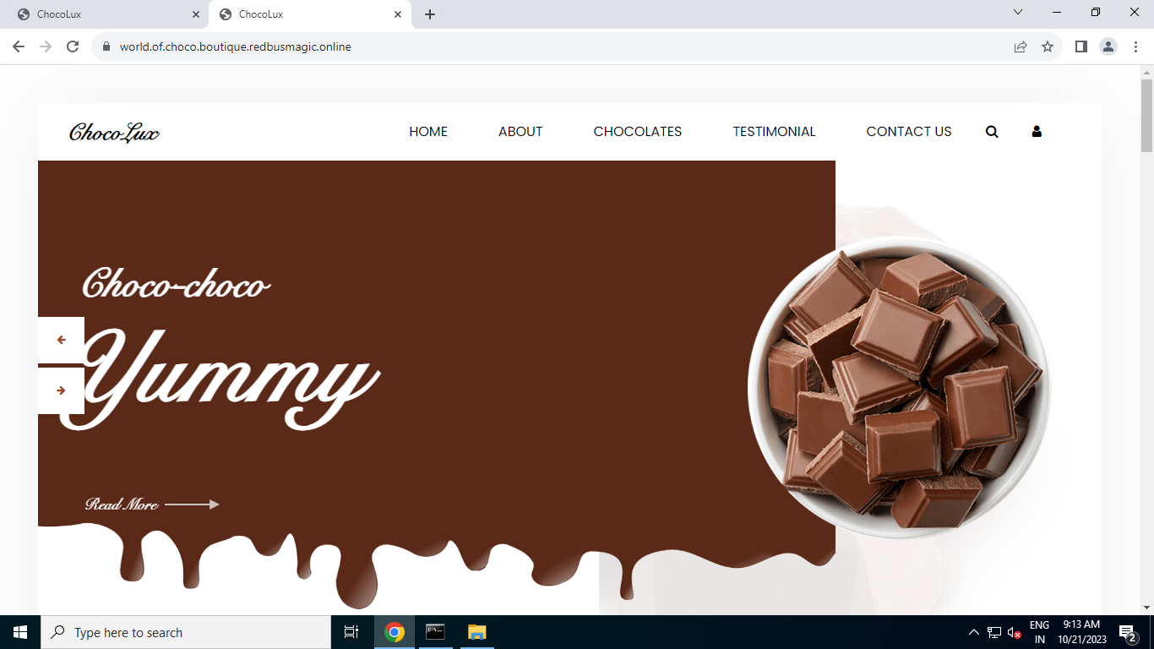

Access granted to VM1